Assignment

create a user and add the user to the sudoer group.

Creat a directory and a file inside it. Created in the user

put a content inside the file which the user created can read

restrict the user from viewing the file

the assignment was carried out thus

1. i created a new user account using this command

**sudo useradd -m -d *home*/new/ -s *bin*/bash/ new**

i also set the password for the new user using this command

**sudo passwd new**

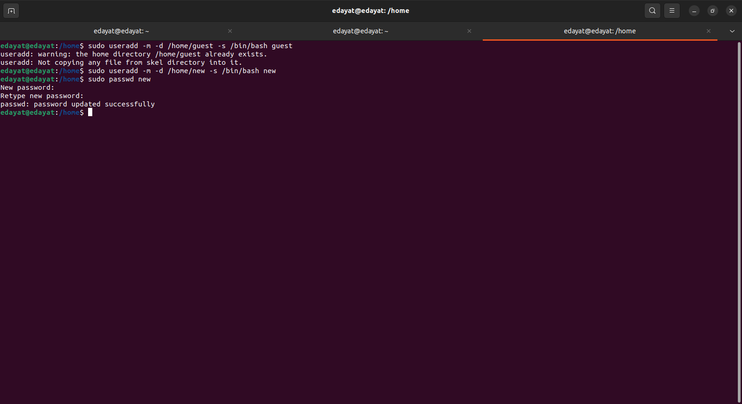

2. 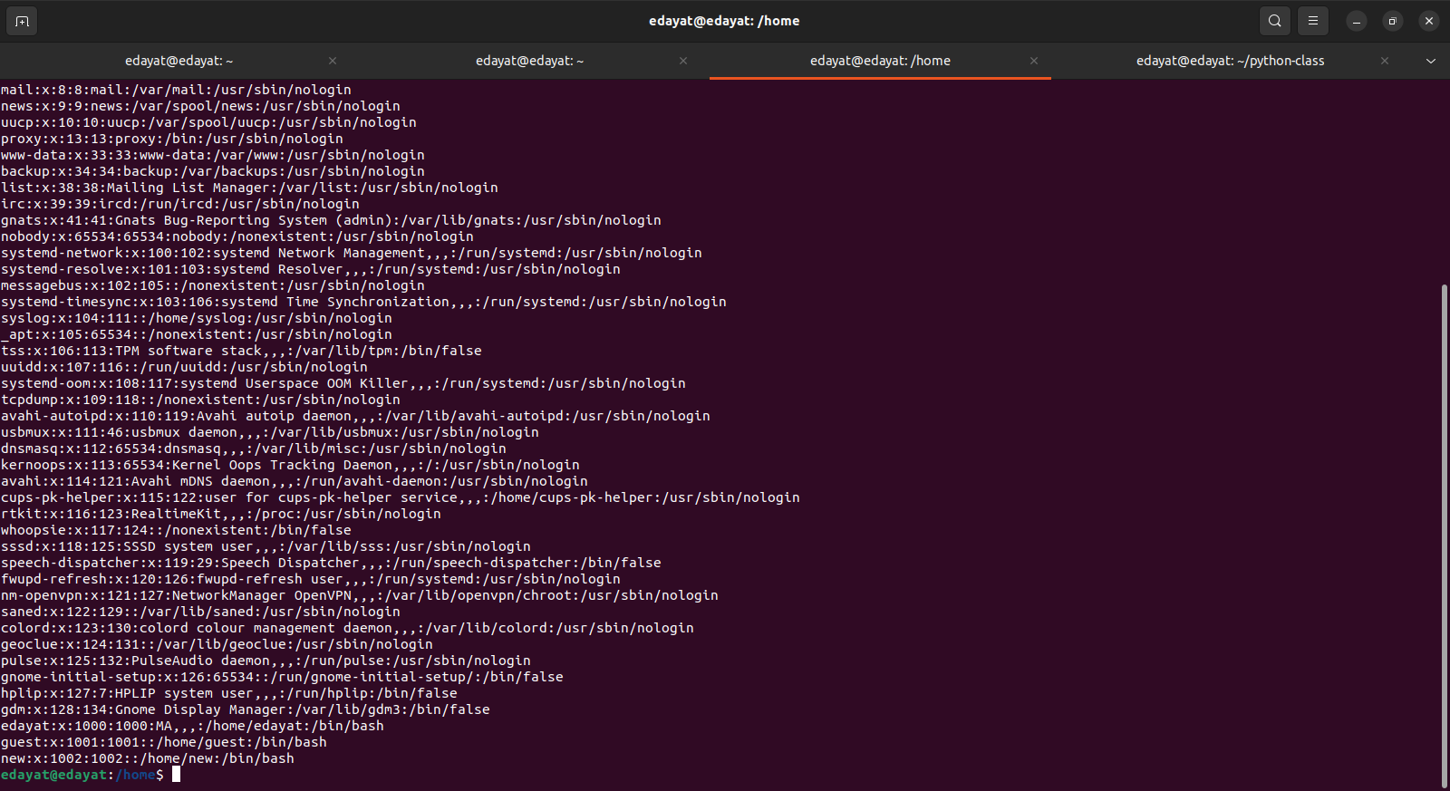I was able to verify that the user was created using this command **cat /*etc/passwd***

*3.* i added the user to the sudoers group using the following commands

**sudo usermod -aG sudo new**

to check if the user has been added i used the command

**id new**

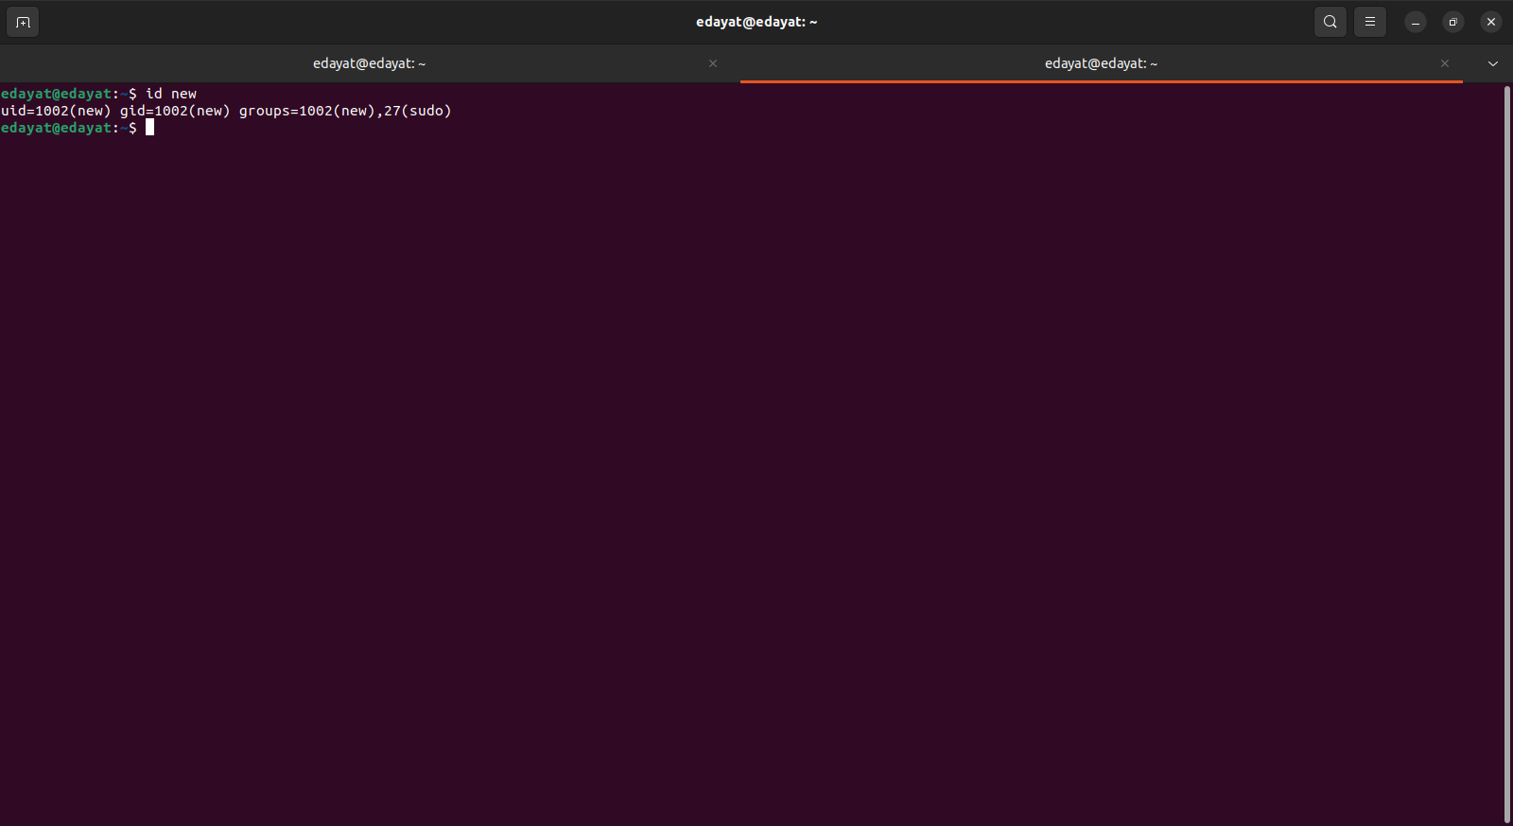

4. i set a passwod for thenew user using this command

**sudo passwd new**

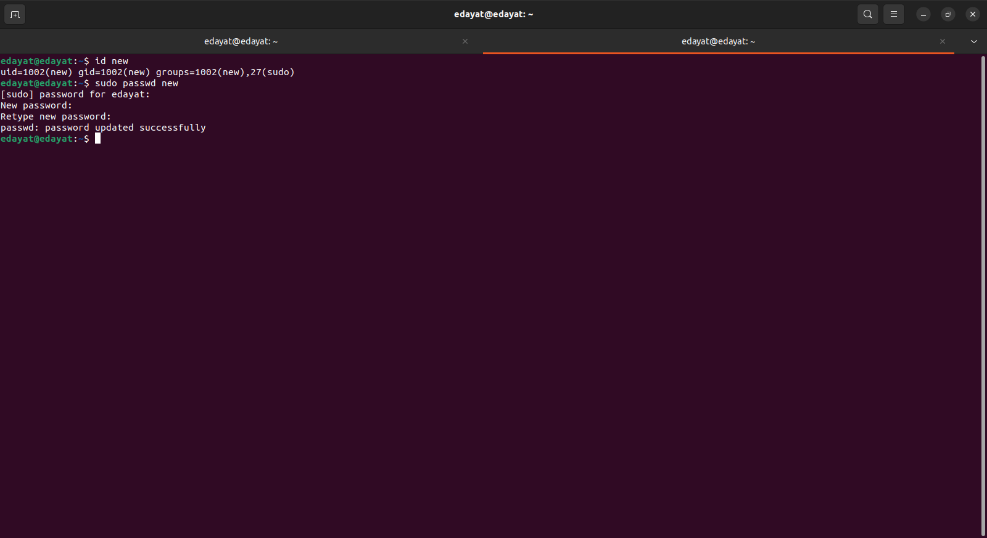

i used the following command to verify if the passwd has been set

**sudo cat /*etc/*shadow**

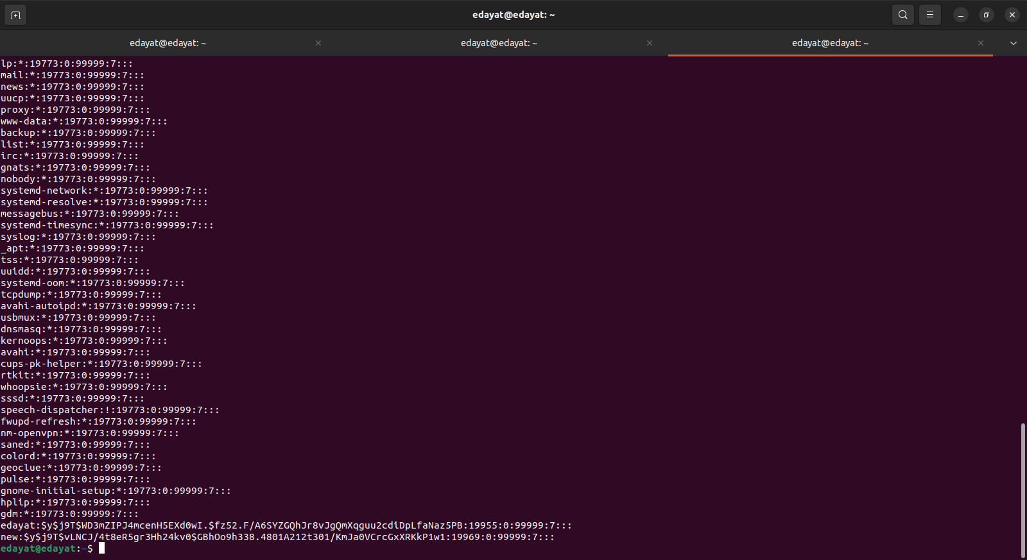

5. i created a directory in the user using this command. First i had to check if the user hadits homedirectory created using

**cd /home .**

Next i transferred the ownership of the home directory to the user in order to be able to execute commands using

**sudo chown -R new:new new**

after that i created the director and also created a file inside it

**mkdir fresh_directory**

**cd /fresh_directory**

**touch fresh_text**

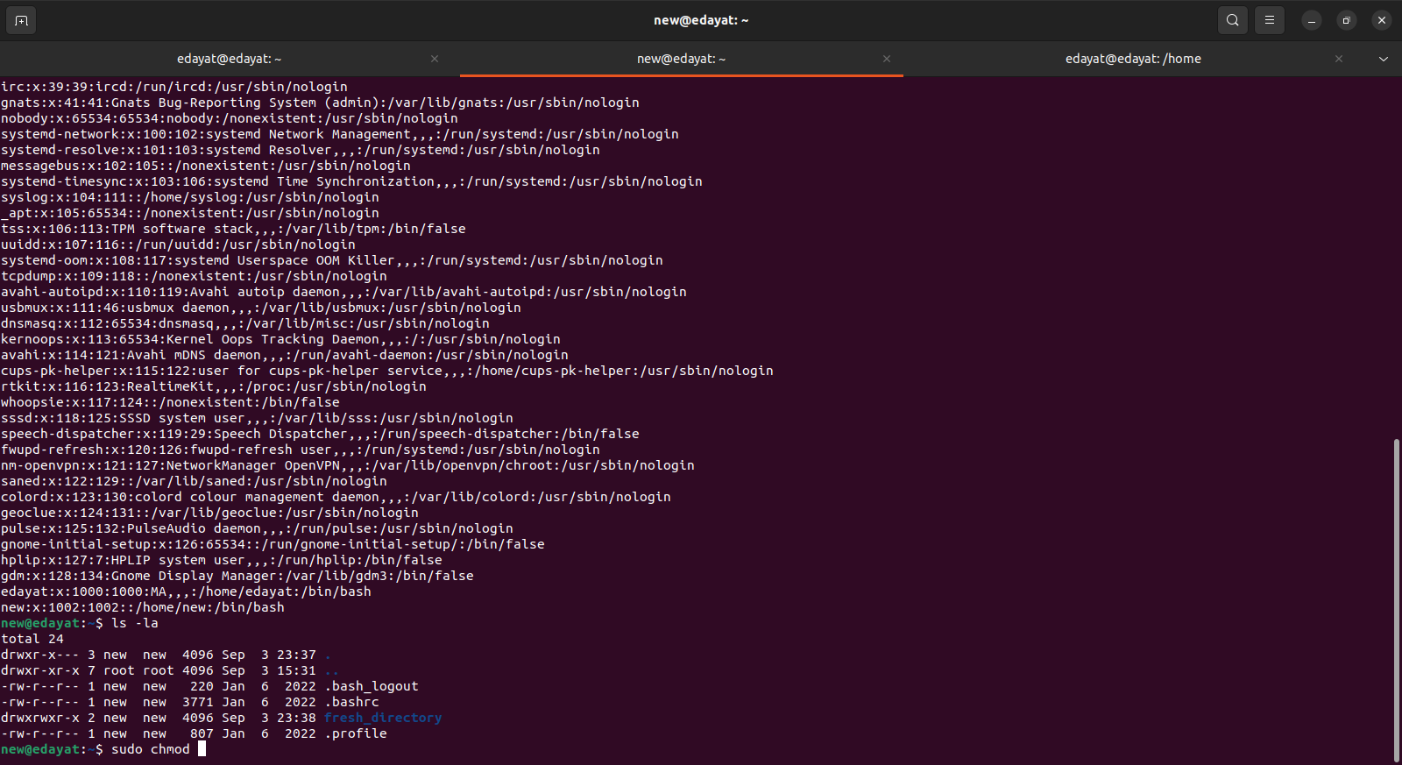

6. i restricted the user from getting the content of the file using

**sudo chmod g-rw fresh_directory**

